**Name -Monika Gariya**

**Email-** [**monikagariya2023@gmail.com**](mailto:monikagariya2023@gmail.com)

**Data Engineering Batch 1**

**Date – 22-01-2024**

**Topic – SQL Correlated subqueries using exist and not exist**

**SQL Correlated Subqueries**

It is a subquery that uses values from outer query. Correlated subqueries are used for row-by-row processing. Each subquery is executed once for every row of the outer query.

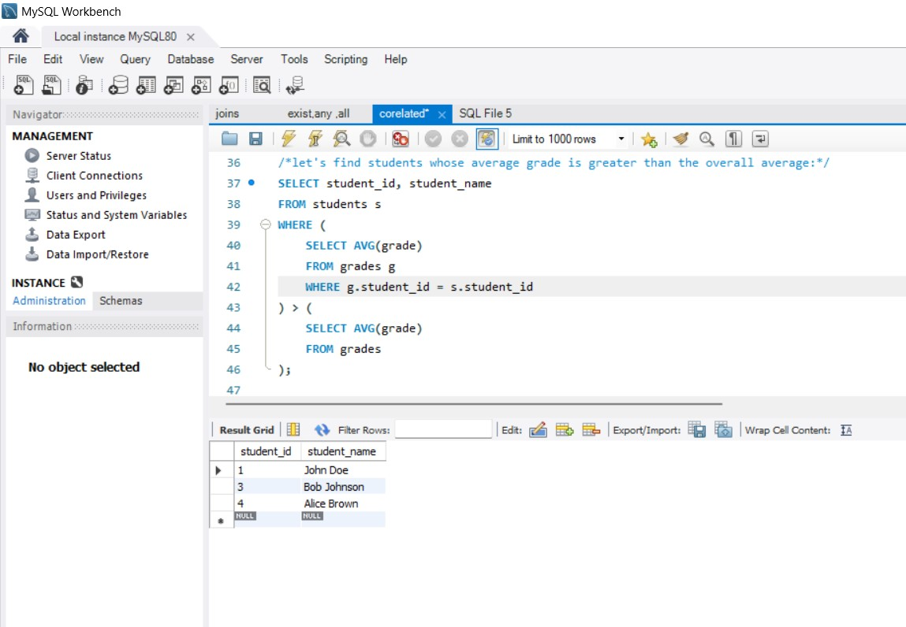

**Using EXISTS with a Correlated Subquery**

EXISTS operator to check the existence of a result of a subquery. EXISTS operator can be used in correlated subqueries also.

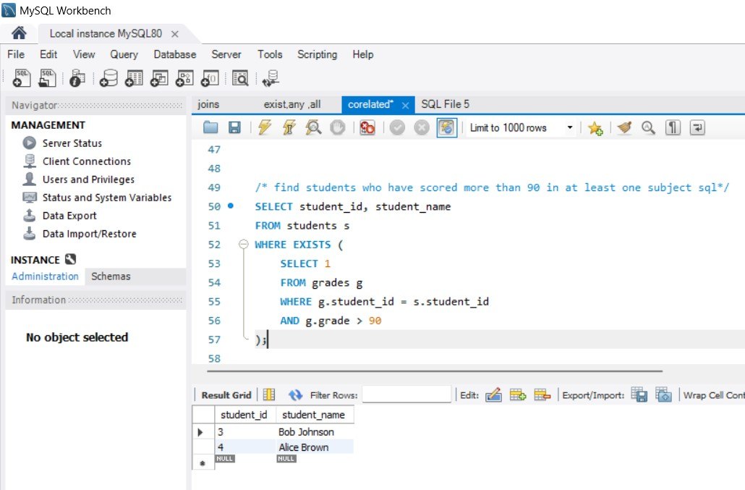

**Using NOT EXISTS with a Correlated Subquery**

NOT EXISTS is logically opposite of EXISTS operator. NOT EXISTS is used when we need to check if rows do not exist in the results returned by a subquery.

